**OZONE LAYER DEPLETION**

The distribution of ozone in the stratosphere is a function of altitude, latitude and season. It is determined by photochemical and transport processes. The ozone layer is located between 10 and 50 km above the Earth's surface and contains 90% of all stratospheric ozone. **Ozone is formed when oxygen molecules absorb ultraviolet photons and undergo a chemical reaction known as photo dissociation or photolysis, where a single molecule of oxygen breaks down to two oxygen atoms. The free oxygen atom (O), then combines with an oxygen molecule (O2) and forms a molecule of ozone (O3). The ozone molecules in turn absorb ultraviolet rays between 310 to 200 nm wavelengths and thereby prevent these harmful radiations from entering the Earth's atmosphere.** In the process, ozone molecules split up into a molecule of oxygen and an oxygen atom. The oxygen atom (O) again combines with the oxygen molecule (O2) to regenerate an ozone (O3) molecule. Thus, the total amount of ozone is maintained by this continuous process of destruction and regeneration.   
 **O2 + hυ O + O**

**O2 + O + M O3 + M**

**O3 + hυ O2 + O**

The ozone layer is essential to life on earth, as it absorbs harmful ultraviolet-B radiation from the sun. In recent years the thickness of this layer has been decreasing, leading in extreme cases to holes in the layer. Measurements carried out in the Antarctic have shown that at certain times, more than 95% of the ozone concentrations found at altitudes of between 15 and 20 km and more than 50% of total ozone are destroyed, with reductions being most pronounced during winter and in early spring. Natural phenomena, such as sun-spots and stratospheric winds, also decrease stratospheric ozone levels, but typically not by more than 1-2%.

Ozone layer depletion first captured the attention of the whole world in the later half of 1970 and since then, many discussions and researches have been carried out to find out the possible effects and the causes of ozone depletion.

**7.7.1 CAUSES OF OZONE DEPLETION**

The cause of ozone depletion is the increase in the level of free radicals such as hydroxyl radicals, nitric oxide radicals and atomic chlorine and bromine. *The most important compound, which accounts for almost 80% of the total depletion of ozone in the stratosphere are chlorofluorocarbons (CFC) such as CFC-11, CFC-12*. Other compounds which are responsible for ozone layer depletion are halons (halons are bromo-chloro-fluorocarbons or bromo-fluorocarbons that are widely used in fire extinguishers) and methyl chloroform, methyl bromide, carbontetrachloride solvents produced from industrial sources. [Chlorofluorocarbons](http://www.ace.mmu.ac.uk/eae/ozone_depletion/older/CFCs.html) are not "washed" back to Earth by rain or destroyed in reactions with other chemicals. They simply do not break down in the lower atmosphere and they can remain in the atmosphere from 20 to 120 years or more. As a consequence of their relative stability, **CFCs are instead transported into the** [**stratosphere**](http://www.ace.mmu.ac.uk/eae/ozone_depletion/older/Stratosphere.html) **where they are eventually broken down by** [**ultraviolet**](http://www.ace.mmu.ac.uk/eae/ozone_depletion/older/Ultraviolet_Radiation.html) **(UV) rays from the** [**Sun**](http://www.ace.mmu.ac.uk/eae/ozone_depletion/older/Sun.html)**, releasing free chlorine. A free chlorine atom reacts with an ozone molecule (O3) and forms chlorine monoxide (ClO) and a molecule of oxygen. Now chlorine monoxide reacts with an ozone molecule to form a chlorine atom and two molecules of oxygen. The free chlorine molecule again reacts with ozone to form chlorine monoxide. The process continues and the result is the reduction or depletion of ozone in the stratosphere.** Once in the stratosphere, every

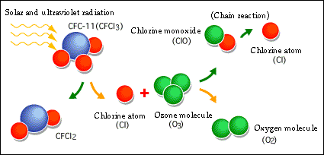chlorine atom can destroy up to 100 000 ozone molecules.

**Figure 7.5 :** **Mechanism of ozone layer destruction by CFC in stratosphere**

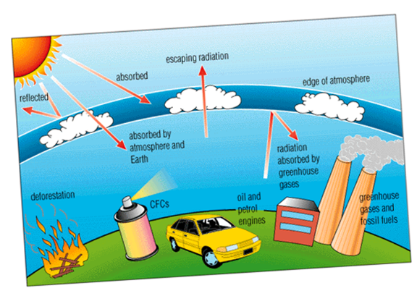

**Figure 7.6:** **Human activities which cause depletion of ozone layer**

**7.7.2 EFFECTS OF OZONE LAYER DEPLETION**

The main potential consequences of this ozone depletion are:

* **Increase in UV-B radiation at ground level:** a one percent loss of ozone leads to a two percent increase in UV radiation. Continuous exposure to UV radiation affects humans, and can lead to skin problems (ageing, cancer), depression of the immune system, and corneal cataracts (an eye disease that often leads to blindness). Increased UV radiation may also lead to a massive die-off of photoplancton (a CO2 "sink") and therefore to increased global warming.
* **Reduction of the ozone greenhouse effect:** ozone is considered to be a greenhouse gas. A depleted ozone layer may partially dampen the greenhouse effect. Therefore efforts to tackle ozone depletion may result in increased global warming.
* It can affect animals and plants as well. It can affect important food crops like rice by adversely affecting cyanobacteria, which helps them absorb and utilize nitrogen properly. Phytoplankton, an important component of the marine food chain, can also be affected by ozone depletion. Studies in this regard have shown that ultraviolet rays can influence the survival rates of these microscopic organisms by affecting their orientation and mobility.
* Disturbance of the thermal structure of the atmosphere, probably resulting in changes in atmospheric circulation.
* Changes in the tropospheric ozone and in the oxidizing capacity of the troposphere.

International targets for the reduction of ozone depleting substances have resulted in the almost complete phasing out of CFCs, halons and carbon tetrachloride. Methyl chloroform and methyl bromide will be phased out by 2005 and HCFC by 2040. The increasing concern for the causes and effects of ozone depletion led to the adoption of the Montreal Protocol, in the year 1987, in order to reduce and control the industrial emission of chlorofluorocarbons. International agreements have succeeded to a great extent in reducing the emission of these compounds, however, more cooperation and understanding among all the countries of the world is required to mitigate the problem.

**7.7.3 The Antarctic “Ozone Hole”: A Case study**

The severe depletion of stratospheric ozone that has occurred every year since the 1980s during Antarctic springtime is known as the “ozone hole.” This hole is created by the reactive gases containing chlorine and bromine that destroy ozone. The ozone hole was discovered in the early 1980s by researchers making ground-based measurements of the ozone above this region. The depletion of the Antarctic ozone layer occurs because of the interactions of ozone-depleting substances in the unique weather conditions that exist only in this region. The very low temperatures of the Antarctic stratosphere create ice clouds called polar stratospheric clouds (PSCs). Special reactions that occur during springtime on these clouds, along with the relative isolation of polar stratospheric air, allow chlorine and bromine reactions to produce the ozone hole. Amounts of ozone are often described in terms of the thickness of ozone in a column of air that stretches from the Earth’s surface to the top of the atmosphere. *The most common measurement of total ozone values in the column are called Dobson units (DU).* One DU is equal to the number of molecules of ozone that would be needed to create a layer of pure ozone 0.01 millimeter thick. Typical amounts vary between 200 and 500 DU around the world. The total ozone value of the ozone hole is only 100 DU. This is equivalent to a layer of pure ozone gas on Earth’s surface having a thickness of only 1 millimeter (less than one sixteenth of an inch).